DOTNET FULL STACK DEVELOPER COURSE
_IN 90 DAYS

Why only dotnet ?
- Because it is faster than remaining full stacks.
- Present DotNet is platform independent.
- It called as DotNet core.
System Requirments
- Os :- windows 10/11
- Ram :- 8gb+
- Storage :- 256gb sd
- Cpu :- inte i5
90-Days plan
Week 1-3 Frontent Html5,Css3,Bootstrap
Week 4-6 Javascript,Typescript,Angular
Week 7-9 c# core & sql database
Week 10-12 .Net core Api & placement
HOW THE INTERNET WORKS ?
- In olden days 1gb coast is higher.
- Now 1bg is around 18rs.
- Everything is connected through c-cables.
tracert
- This is used for to check the internet speed of the any website.
- In command panel enter (tracert website name).
- It shows how the website networks at backside.
- Aslo through IP-Address.
google.com →DNS → IP_Address
DNS – DOMAIN NAME SERVER

GO-DADDY
- It is a domain hosting platform.
- We can rent for domain. N
ipLocation.net
- To check the ip-address where it was going.

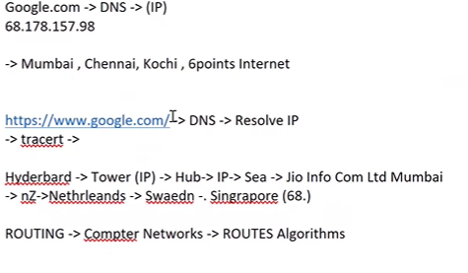
How Internet Balance,File size
- 1Byte = 8bits
0 0 0 0 0 0 0 0
2^7 ….. 2^0 – it will double when it goes to left
128 64 32 16 8 4 2 1
= 255

0 0 0 0 0 0 0 0 = 8bits only

a = 5;
b = 6;
c = a+b;

0 0 0 0 0 1 0 1 = 5 – here there is no allocation 5 bits storage directly so as per storage 5 is more close to 4th position in storage block
So – 0 0 0 0 0 1 0 1 = 5
0 0 0 0 0 1 1 0 = 6 – means 4th +2th positon
0 0 0 0 1 0 0 1 = 8th + 1th = 9
0 0 0 0 1 1 0 0 = 8th + 4th = 12
1 1 1 1 1 1 1 1 = 255

2^7 – 2^15 = 2bytes range (when we increase number size the storage also increases)
- All values are presented in only 2 powered values

- 1 BYTES = 8BITES
- 1kB = 1024BYTES
- 1MB = 1024KB
- 1GB = 1024MB
- 1TB = 1024GB

Image storage calculation
- Base64 Guru -> this is the website that gives (Encode image to Base64) portion it gives image code then paste it in Notepad
- To find the image 0&1’s we find ASCII values
ASCII VALUES
- American standard code for international interchange

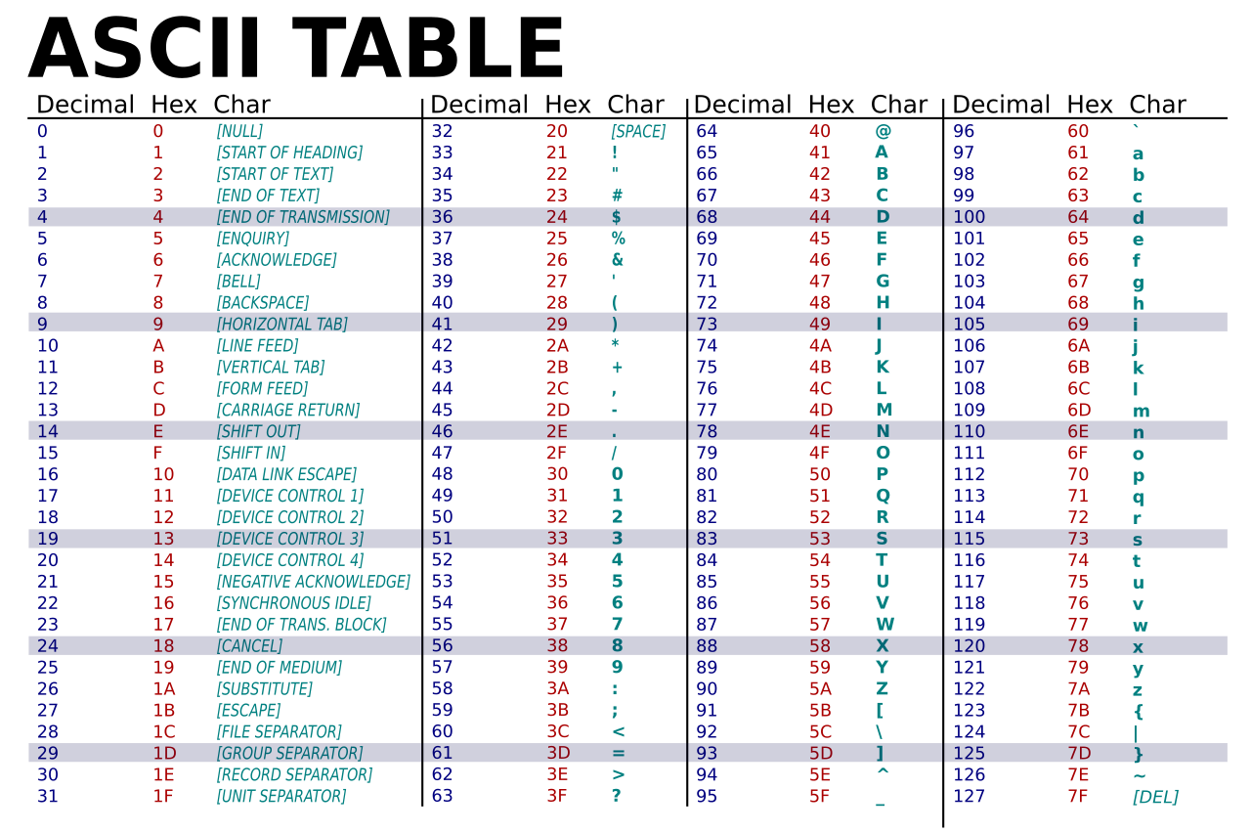
- Every value as asci value so we had ascii coked value to every file
- Every value is totalled means it is file size calculated.
- Website called htmlcolorcode go to that and calculate.

NO VIDEOS THOSE ARE IMAGES THAT MOVIES LINE SO THAT WE CAN SEE AS VIDEO,
IMAGES -> FRAMES -> REELS -> FAST_MOVE -> VIDEO
HTTP
- Hyper text transfer protocol
- It is hackable
HTTPS
- Hyper text transfer protocol secure
- More secure than http
- To check whether a website is secure or not
  - Click on the toggle button before the link so there will be connent secure option so this will have the secure certificate

COMPUTER SCIENCE ECOSYSTEM
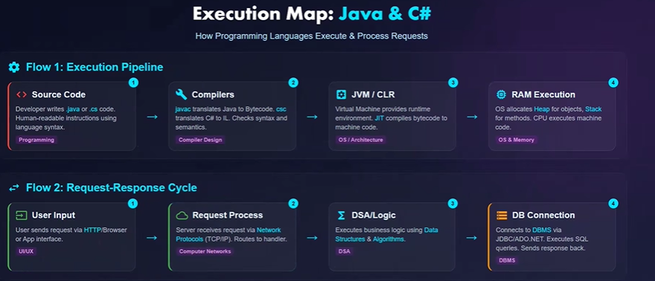

PRINT_STATEMENT
- Console.writln(“sai”) - c#
Alt + Tab
- This is used for to swith b/t one app to another app

- Load to ram volatile memory not saved permanently (RAM)
- Permanent storage is memory or harddisk(rom).
- Memory allocation 1kb_file allocated in RAM on exection completed I will wrase memory in RAM
- If we not saving it,it will not store in ROM (permanently) so without saving

OS CPU ALOCATE WORK
OS ALLOCATE HEART OF COMPUTER COMPUTER CALCULATION MECHANISM
FRONTEND
HTML CSS JAVASCRIPT TYPESCRIPT ANGULAR REACT
BACKEND
DOTNET C# SQL SERVER EF CORE AZURE CLOAD

UNDERSTAND_BROWSER
- URL – Uniform Resource Locator.
- When we want to get any website link should be type in url-position like (amazon.com) that box is called search_tab it should be secure as above.
- Element in inspect toll we have our all html code
- <html>wherething we write in both of these</html>
- Console we have javascript code
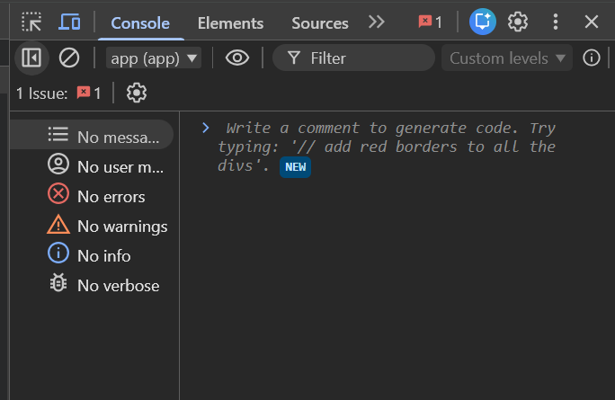
- This is used remove error from js code
- Network is used to check server call
- Sources is used to check the private code & debug (ctrl+shift+p) to check our branced code.
- Performance how much it user taking to load website.
- Memory it is used to check the total website size means how much it take to store all the images and extra things
- HeapSnapShot we can take all the data from website.
- LightHouse is used for SEO – search engine optimization and mainly used by business analylist.
- RECORDER used for to test the website, we can record the web working at get it,used by manual_testers
- Components it is React_js things.
- Cookie_Editor it is used to preference mean the importance for user given by developer means indian user need to important first.
- Three_Doits and in it Dock_side it is used for to change web console to where ever we want
- Style it is used manuplate css styling,we can remove styles.
- Computed it is used check and kind of component is style with what size
HTML5
- Browser will understand html very easly
- <!DOCTYPE html> it is a version of html tell that it is a document to the browser.
- <html></html> it is the main html we write everything in it,it is a when we keep anything in it it is a document,where many documents linked to one url- uniform resource locator, to check go to console type (document) it will give us a link of the website
- <head></head> it is used for to code the title,tells the data about the website.
- <title></title> it is used for to give name to the website.
- <body></body> it is used for to write everything.
Sample_Code :-
<!DOCTYPE html>
<html>
<title>
This is learning
</title>
<body>
<p>HII</p>
</body>
</html>
- Here we need to create a new file open it in vscode so here
Step_1 create a file any name
Step_2 In search panel type cmd
Step_3 cmd get open then type(code .)
Step_4 vscode get open
Step_5 we can create html file in it.
- In the above the space is a tree structure means a parent and child anolgy.
- Means in above html as head as child and head as title as child
- Wherething we have in html is a object means each tag is a object the inside tag in it is a property.
- <head> opening_tag of the html document
- </head> closing_tag of the html document.
- Should be opening tag means it should be close.
- <p name=”name”> name we write in it is an attribute,the thing or text in the(“”)is a value of the attribute.
- Only in opening tag we need to write the attribute only.
HEADING_TAGS
- Heading tags are used for keep text more bolder and big in size,we have h1 to h6 size dereacese while going doven.
- <h1>heading</h1> - 32px
- <h2>heading</h2> - 24px
- <h3>heading</h3> - 18px
- <h4>heading</h4> - 16px
- <h5>heading</h5> - 13px
- <h6>heading</h6> - 11px
PARAGRAPH_TAG
- It is used for write a page of content in website
- It takes line spacing front and back of the line.
<p>paragraph</p>
BRAEK_TAG
- it is used for to move the inline elements next to another.
<br>
BOLD_TAG
- It is used make text bolder and thicker then remaining text.
<b></b>
ITALIC_TAG OR EM_TAG
- Make text into italic font
<i></i>
<em></em>
SUB_TAG
- It is used for to move text into base
<sub></sub>
SUP_TAG
- It is used for to send number to power
<sup></sup>
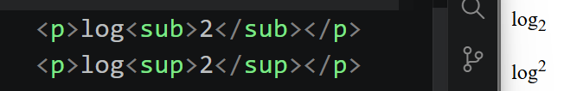
DEL_TAG
- It is used for deleted line means a line through the text.
<del>this is a wrong</del>
INS_TAG
- It is used to insert text side by side means when we want to add a purpose of the particular thing we use this
<ins>click</ins>
STRONG_TAG
- it is also used to make text bolder.
<strong>it is bolder</strong>
HTML_COLOR_CODES
- a websites that help us to check the color_code.(htmlcolorcodes.com) it is the website.
- This is only work when we give (#)infront of code.ex:- (#023828)
- hsl is also a color code hsl()
DIV_TAG
- It is a divison tag that divide website with no of block
<div></div>
- It is a block level element
- It will take total website lenth for its element
SPAN_TAG
- it is a span same use of div
<span></span>
- it is a inline element
- it take only necessary.
ALL THE BASIC TAGS ARE INLINE ELEMENTS
LIST_TAGS
- list are basically two types one is ordered_list and unordered_list
<li></li> it is comman for every list
ORDERED_LIST
- it will have an oder to the items and it gives numbers to the items.
<ol>
<li>one</li>
<li>two</li>
</ol>
- in ol we have(type=”i”,type=”1”)
UNORDERED_LIST
- it has only points in it
<ul>
<li>one</li>
</ul>
DESCRIPTION_LIST
- we can give a description for list items
<dl> DescriptionList
<dt></dt> DescriptionTitle
<dd></dd> DscriptionData
</dl>
IMAGE_TAGS
- it is used to add image in website
<img src=”./link of the image is here”/>
Width = “width of the image”
Height = “height”
- Here when we want to come back to any file we need to do that(../) one step back means come back to the out of file (../…/) we can come back to the out of the file,this process is called RELATIVE PATH.
- Copying the path from fileManger properites fileLocation_copyPath
HYPER_LINK & ANCHOR_TAG
- When we add link means it redirect to another page
<a href=”the actual link is here”>dummy text</a>
- If it open on the same it is not good so here
- We add (target=”_blank”) this help us for new page
- (target=”_self”) this helps us for open link in same page
- Here if we give <a href=”tel:OurOwnMobile”> it wil directly go to call pad
- Here same as above <a herf=”mailto:OurEmailId”>
HTML_HEADER
- <meta charset=”UTF-8”></meta>used for website language means if we move the password as it is it will hack so this will change to encode so it is never hackable
- <meta name=”viewport” content=device-width,initial-scale=””1.0”> it is used for responsive web design.
- Scale =”1.0” it is used for size of the website.
- <title></title> it is used for to give name to the website.
- <style></style> used to customize the website,css items can written in this.
- <link></link> it is used for linking an external file to this it is also a self_closing tag <link/>
- <link rel=”shortcut icon” href=”./link of the image” type=”image/x-icon”> it will have many links used many uses like css linking but rel = “shortcut icon” is used for giving the icon for website before it’s title.
SEO
- It is used for fast reach in website,by this we can easly pop when some one reach our website
<meta name=”keywords” content=”frontend”>
- Here if we can give anything means what user can searc so we can that names many tags we can create like this
FORMS_TAGS
- It is used for taking input from user
<form>
</form> everything is written in it only.
<input type=”text” name=”firstName” id=”firstNameId”> it is used to take text input from user,name and id can be anything
<input type=”file’ name=”UploadAFile” id=”id”> it is used to take file as input from user.
<input type=”submit” value=”submit”/>it is used for to submit the form.
<input type=”checkbox”> it is used for select options.
<input type=”color”>it is used to select color
<input type=”date”> used to select date.
<select> used to selecting
<optgroup> it groupt the wanted items
<Option></option> the items should be in it.
</optgroup>
</select>
<fieldset><fieldset> it is used for to group the form means it will keep the form in the box.
<legend></legend> it is used for to set the name to the box.
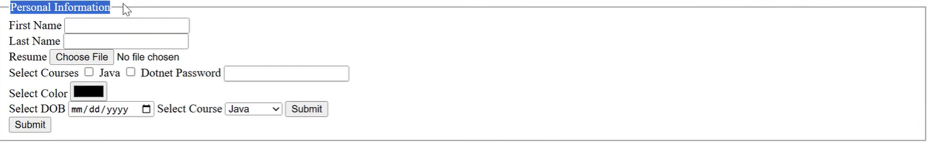
<textarea rows=”we can” column=”we can give”></textarea>used to add paragraph in the forms
LABEL_TAG
- it is used for to keep text that the input field was doing
<label for=”this is for it ask for which I am label of means where should label for is used for that,we should give (name,id values)”> anyText </label>
BUTTON_TAG
- it is used for a manual button that used to take user input and submit it.
<button> Submit </button>
TABLES_TAGS
- it is used to keep data in an tabler format.
<table>table to create
<thead> it is used for table head
<tr> table row
<th>Name</th> table heading
<th>age</th>
</tr>
</thead>
<tbody> it is a table body
<td></td> table data
</tbody>
</table>
- rowspan=”cellNo” it is used for occupying the cell means if 3 cells same data so it should be (23) the 23 is used.
- Colspace=”cellno” Same as rownspan but it is used for column it self,we can do until the table length.
- for border we give <table border=”1px”></table>
IFRAME
- Embedd or keeping one website in another website.
<iframe src=”link of the website” width=” ourOwn” height=”ourOwn” allow=”*” referrerpolicy=”none” allowfullscreen ></iframe>
<meta name=”theme-color” content=”color”>
It is used to set browser default color as website color.
HTML5 INTRODUCTION
- Difference b/t HTML and HTML5,the difference is semantic tags.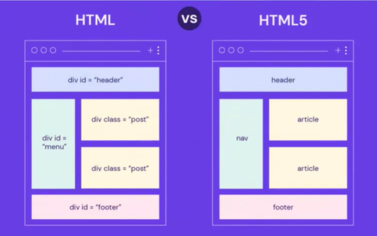
SEMANTIC_TAG
<header></header> → top section of webpage
<nav></nav> → navigation links
<main></main> → main content
<section></section> → grouped content
<article></article> → independent content/article
<aside></aside> → side content
<footer></footer> → bottom section
HTML5_FORMS_FEATURES
- Placeholder =”Eneter Your Name” it is used tell that what is that box is doing in it field.
- Required it tell’s this field is complasary,also used validation.
- Autocomplete=”on OR off” it is used for asking the previously entered data drom that field.
- Hidden it is used to hide means it will be there but not present in web.
- Tabindex=”0”by default it will move naturally tabindex=”positive_value OR negative_value” it is used for tab-key means when user user is using tab to jump in form but we should not allow it we use this.
- Contenteditable =”true OR false” it is used for when we want to edit any text in web we keep in this in opening tag of that field,it will change present there only.
- Pattern=”[0-9]{10}”it is used for we need send particular format for any digits so we use this,[0-9]this says this is only for 0-9 elements {10} how many digits it should.
- <input type=”email”> it is used to take input from user.
- <input type=”tel”> it is used for taking telephone numbers.
- <input type=”date”> it is used to take date like DOB.
- <datalist></datalist> it is used for search dropdown means in an input field we can add dropdown method means we can add <select></select> in an field and it is also used for search and get the value from dropdown in select_list we need search manually,it is used for that.
<input list=”AnyName”>
<datalist id = “listName and id should be same only ”>
<option value=”java”>Java</option> here the search is happened only by value in option field so value and the name inside should be same.
</datalist>
- <canvas id=”ok” width=”300px” height=”300px”></canvas>
(Tips javascript should not run before its variable is not present means if the html id is using in js so the js should not run before html.)
SVG(scaler,vector,draphics)
- Every icon is an svg.
<svg>
<rect x=”10” y=”20” width=”150” height=”100” fill=”red”>
<rect x=”10” y=”20” width=”150” height=”100” fill=”red”>
</svg>
- It is a lengthy code so we have (svg_icons)
  - websites(Svgrepo.com)
  - path in svg important so here we can if we want to edit it we have
  - google search (svg path defiter) gitrepo (yqnn.github.io/svg-path-editor/)
  - to change the color of the icon we should do <path fill=”anyColor”></path>
AUDIO & VEDIO
- this is used to add audio and vedio track in website.
<audio src=”linkofthesong” controls autoplay></audio>
controls this is used to add controls for audio means stop,volume,download.
autoplay this is used play automatically when page on.
<video src=”linkofthesong” controls autoplay></video> Both as same things same work process.

CSS
- CASCADING_STYLE_SHEET
- The css is like dress means cloths to the human.
- We can apply the style to the any web application and for any element in html.
- There are 3types of css to use for html
INLINE_CSS
- we write css code in html tag
<p style=”color:red; border:2px solid red”></p>
- we can write many properites,but after (;)only.
INTERNAL_CSS
- the css is written in between
<style></style> tag
<style>
P{
Color:red;
}
</style>
EXTERNAL_CSS
- this is written code by linking it outerly
- this is used for clear code for html,css separtly.
<link rel=”stylesheet” href=”./ actual_link of the css”/>
- we can also add one css to another css by(@import url(‘link of the wanted css.’))
- /* this is a comment syntax*/
- List styling(List-style-type:anything;)
SELECTORS
- it is used for to target a particular element or a tag and style.
TAG_SELECTORS
- it is used for direct attak on the tag means we can give the tag and style it
- but if 4 h1 tags means it applys to all of it.
Syntax :
h1{
Color:red;
}
- we can add muiltiple tags at onces h1,ol,li,h2{
color:red;
}
CLASS_SELECTORS
- here it is used to style a separate tag in same named group tags
- we can add class=”anyname”,here class selector can have same name to many tags
HTML class=”one”
CSS .one{}
- here (.) is used address class
ID_SELECTORS(most priority )
- id aslo used used like class but id is very unqiue only one name to one tag same will not accept
HTML id=”one”
CSS #one{}
- here (#) is used address class

BOX_MODEL
(PADDING,BORDER,MARGIN)=BOX_MODEL.
- Padding – kalli_sthalam.
- Border – intiki prahari.
- Margin – space b/t your sthalam and another sthalam.

margin
border
padding
content

PADDING
- it is used for to give space in b/t content and border.
Padding-left : 20px;
Padding-right : 20px;
Padding-top:30px;
Padding-bottom:30px;
shortcut
Padding:20px(top) 20px(right) 20px(bottom) 20px(left);

BORDER
- it is for to give a outline to the content
border-style
it is used for to add style to the outline of the border
Border-style:dotted;
Border-style:dashed;
Border-style:solid;
border-color
it is used to add color to the outline.
border-width:20px;
Border-color:any-color;
border-width
it is used for thickness of the outline.
shortcut
border:3px solid red;
All sides properities
boder-left: 3px solid red;
border-right:4px solid green;
border-top:3px solid yellow;
border-bottom:3px solid red;

MARGIN
- it is used for space b/t content and content.
Margin-top:20px;
Margin-bottom:20px;
Margin-left:20px;
Margin-right:20px;
shortcut
margin: 20px 20px 20px 20px;
BOX-SIZING
- box-sizing:content -box;
it is used for how much size is given for content the extra-size will be allocated to it,means it overflow more than the given size.
if the width is 400px border is 30px it is 430px.overflow.
box-sizing:border-box;
it is used for to stop the overflow of the size means it stops out of the size means if we give 400px it will adjust in it.
Border-image
- it is used to add image to the border
border-image:url(link_of_the_image);

border-top-left-radius
- used for to make the edges smooth where means top left side edge.
border-top-left-radius:20px;
border-top-right-radius
- used for make edges round or smooth at top right side
border-top-right-radius: 20px;
border-bottom-left-radius
- it is for to make bottom left edge smooth.
Border-bottom-left-radius: 30px;
Border-bottom-right-radius
- it is for making right bottom sharp
border-bottom-right-radius: 20px;

BORDER-RADIUS
- it is for to make all sides sharp.
border-radius:20px;all sides

OUTLINE IN CSS
- it is like boder but use it for sepate element,always used for to focus it
outline:2px solid red;

FONT_SIZE
- it is for increase or decrease the font size of the text
font-size : (any)px ;
- website default size is 16px

FONT_FAMILY
- it is used to change the text style means handwriting
font-family : any-font we want;
- For best font we use (google_fonts) website.
FONT_WEIGHT
- The thickness of the font
Font-weight:20px;
TEXT_ALIGN
- It is used for to place text on which side we want
Text-align: center;
TEXT_DECORATION
- Used to decorate text
Text-decoration: underline;
TEXT_TRANSFORM
- Here it is used for make text capital and small
Text-tranform : capitalize;
Text-transform : lower;
TEXT_OVERFLOW
- It is used not to move txt outside the box.
Text-overflow : inhert ;
TEXT_SHADOW
- It is used give shadow to the text
Text-shadow: 30px 20px 20px rgb(0,0,0);
TEXT_INDENT
- It is used add space to the space to the first line.
Text-indent : 02px;
LINE_SPACING
- It is for space b/t line to line.
Line-spacing:2;
WORD_SPACING
- It is for space b/t word to word
word-spacing : 2 ;
LETTER_SPACING
- It Is used for space b/t letter to letter
Letter-spacing : 2;
COLOR
- To change the color of the text
Color:red;
BACKGROUND_COLOR
- Used to change body color of the website
Background-color : red;
BACKGROUND_IMAGE
- It used to add image to background ethier body or any element.
Background-image : url() ;
LINEAR_GRADIENT
- Used to add or mix more than two colors.
Background-image: linear-gradient(to right , red,green,blue);
To right – means the first color should be right side only, the first color only change
To left – measn the first color moves to left isde.
BACKGROUND_ATTACHMENT
- Used to for scrolling the website means control the background position.
Background-attachement : scroll; it automatically scroll
Background-attachements: fixed; it will fixed the image or element will be fixed at a position.

BOX_SHADOW
- Here it is used for make the shadow to box.
- (best website is css-box-shadow-example).

OVERFLOW
- The item that get out of its box is called.
Overflow: auto; it gives a scroll bar
Overflow : hidden ; it will hide the overflowed context.
Overflow : visible ; by default
Overflow : scroll ; it is like if the content is fixed in a box but also gives the scroll bar.

MEDIA QUERIES
- it is very important concepts in css.
- Beasuce it is used for RESPONSIVE web design,means auto adjust according to screen size.
@media screen and (min-width:px) and (max-width:px) and (orientation: portrait){
Responsive_code;
}
@media screen and (max-width) and (orientation: landscape){
}
@media is a syntax
screen means screen of the website
max-width is for if you reach particular size you will do this
and means along with that also do this.
orientation: landscape this is for the position of the website means we can decide here what we are style means for moble or laptop.
potrait means mobile and landscape means laptop
Max-width
0px ────────────────
✅ applies here
768px ────────────────── ∞ 🚫 does NOT apply here
Min-width
0px ───────────────
🚫 does NOT apply
768px ────────────────── ∞
✅ applies here
FLOAT_CSS
- Moving item left or right in same line.
Float: left or right;
- Also it can adjust the items side by side.
COMBINATORS
- The combinators are like siblings in a family,and child anolgy.
- div p{} descentent_selector means it can apply all child elements in a nested parent,child anolgy.
- div > p{} it means only one child can get styles means no style apply to child in child.
- div ~ p{} all sides of child will be get here
- div + p{} here it means after one tag immediate another tag also get same styles.
Div + p{}
here div tag after p so style is applicable to p
only not also to div only to p
Div ~ p{}
it is for in above it only apply for next one this is for it apply for all after div.
Div > p {}
it is used for child in a parent tag then style will not applicable to sub-child in a parent only to direct child.
Div p{}
this is for to apply styles to all sub-childs also.
UNITS
% div width 400 means the item is 10% means 40% in parent,means 10% in parent width.
Rem relative to the root element,mostly used for fonts.(mostly used)
Vw,Vh browser view width and height means the length of website 10vw means 10% in website screen
PSEUDO_ELEMENTS
::AFTER
- this is for adding any content after the orginal content.
::BEFORE
- this is for adding text before the orginal context starts means at the start point.
INPUT:: PLACEHOLDER
- to style the input placeholder.
P::SELECTION
- here selection is the main thing means when we want style the process of selection we use this.
P::FIRST-LINE
- used to style the first line in a paragraph.
P::FIRST-LETTER
- used to style the first letter in the paragraph.
P::GRAMMER-ERROR
- we use when the grammer is error.
P::SPELLING-ERROR
- this is used for spelling checking.
PSEUDO_CLASS
:HOVER
- this is used when we move mouse to the element the changes will apply
.tagName:hover{
    - Any styles.
}
:ACTIVE
- This is used for button when we click the mouse the style will apply.
.tagName:active{}
:FIRST-CHILD
- It is used for li-elements for that to style the first li
Ul li : first-child{}
:Nth-CHILD()
- This is for to style the elements in a list means we can style any child we want.
:VISITED
- When we used a link and we don’t need to use again we use this.
tagName:visited{}

BOOTSTRAP
- It is a css-libery.

